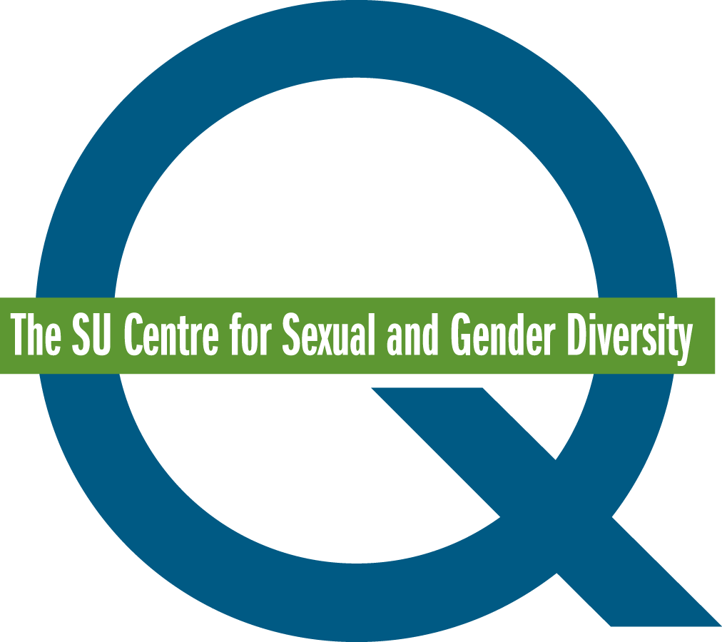

Queer Mentoring Mentor Application Form

The Q Centre’s Queer Mentoring initiative strives to provide sexual and gender minority undergraduate students with opportunities to empower themselves by pairing them with established, queer-identified role models (ie. graduate students, and staff and faculty members). The mentees will work with their mentors to set, and work towards, professional and social goals. These include goals related to coming out, identity, networking, friendship, dating, volunteering, working, extra-curricular activities, stress, relationship issues, and health and wellness.

The program takes place during the Fall/Winter semesters of the academic year. Mentors must be graduate students, faculty, staff members or alumni at the University of Calgary. They can also be Students’ Union staff members. Their minimum time commitment is 7 hours.

If you are interested in applying to be a mentor, please fill out the application and email it to
qcentre@ucalgary.ca.

Name
Preferred Pronouns
Telephone Number
Email Address
Position at the University of Calgary
UCID Number
Why does this program interest you?

Would you be comfortable helping students set, and work towards, professional and social goals? If so, are there any goals you are particularly interested in? (This information will be used to pair Queer Mentors and Mentees).

What are you looking for in a mentee?

Would you be willing to share personal information with your mentee? Personal information may vary from your coming out story to your dating experience.

What qualities do you think are important for mentors to possess?

Would you be able to contribute at least 7 hours to the program?

Thank you for taking the time to apply for the Queer Mentoring Program!

Please note that not all applicants may be accepted to the program. Acceptance to the program may be determined by the number and match suitability of mentor and mentee applicants.

